**Project Design Phase**

**Problem – Solution Fit Template**

|  |  |
| --- | --- |
| Date | 27 June 2025 |
| Team ID | LTVIP2025TMID31213 |
| Project Name | EduTutor-AI-  Personalized-Learning-with-Generative- AIand-  LMS-Integration |
| Maximum Marks | 2 Marks |

**Problem – Solution Fit Template:**

Traditional learning often fails to address the unique needs and learning styles of each student, leading to reduced engagement and poor knowledge retention.

**Purpose:**

❑ Address the limitations of traditional learning by offering personalized, adaptive educational experiences.

❑ Enhance student engagement and improve knowledge retention through customized learning paths.

❑ Support educators by automating repetitive tasks like grading and content generation, freeing time for meaningful interaction.

❑ Integrate seamlessly with existing LMS platforms to ensure smooth adoption and minimal disruption.

❑ Use generative AI to create dynamic content tailored to individual learning styles, pace, and progress.

❑ Build trust and improve outcomes by providing data-driven insights and consistent feedback to learners and educators.

**Template:**

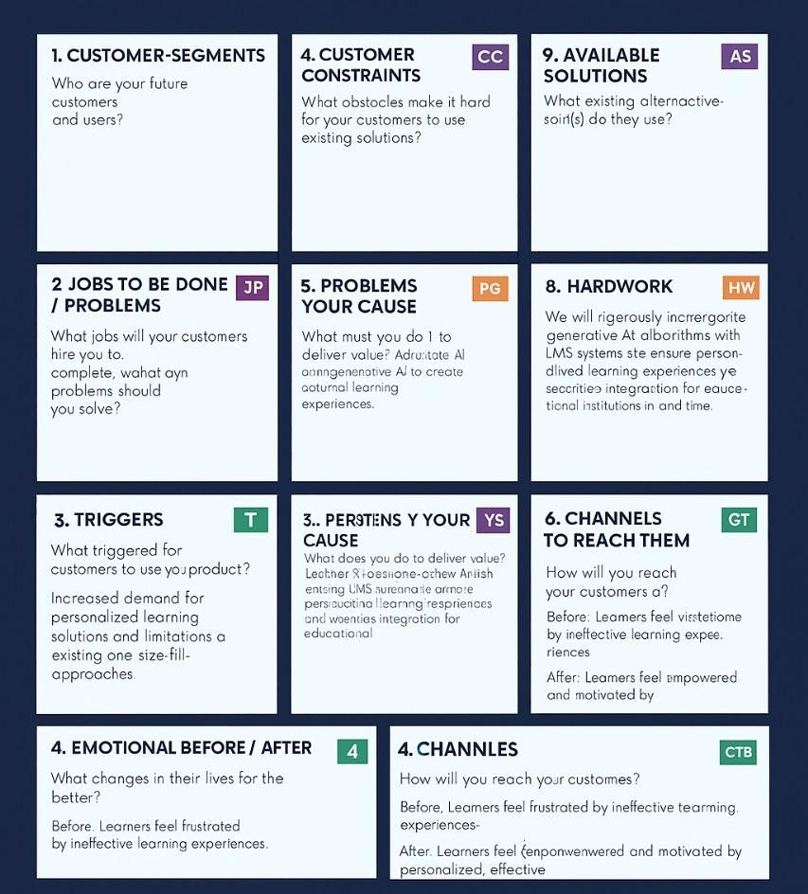

References:

1. <https://www.ideahackers.network/problem-solution-fit-canvas/>
2. <https://medium.com/@epicantus/problem-solution-fit-canvas-aa3dd59cb4fe>